**Test Document for wrong batch no. display in session Purchase Order Invoice Processing**

Testing for IR 787033,

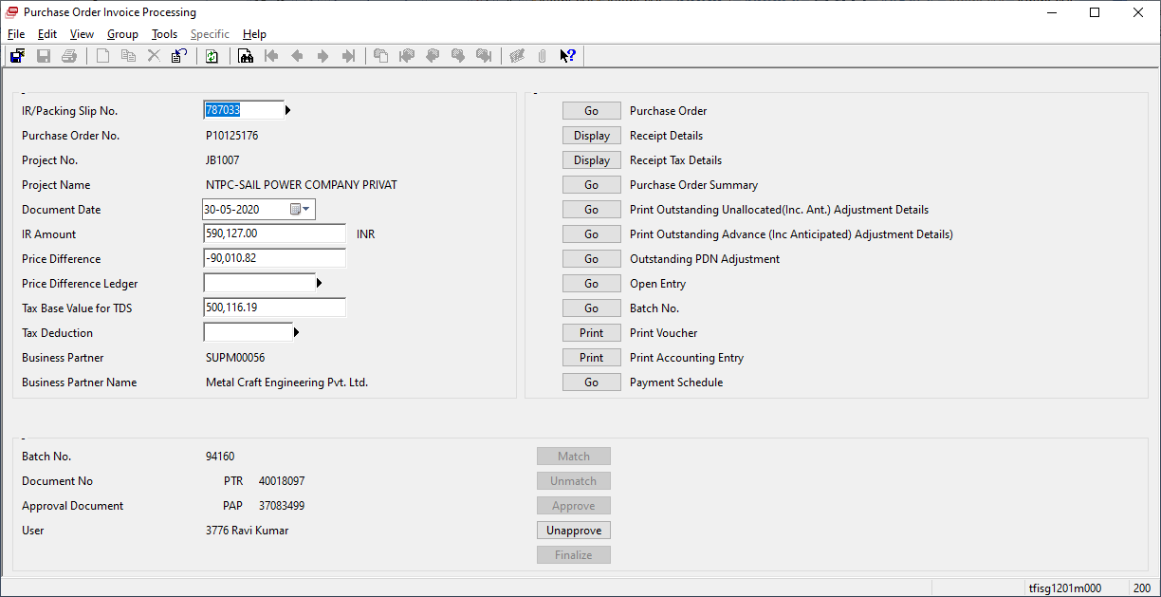

Batch no – 94160

Display Batch no 94160, when PTR-40018097 have two batch no i.e., 94160 and 94158